Rotary Club of Kathmandu Mid-Town
Breakfast Chatter


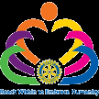

16 December 2011 The Weekly Bulletin of Rotary Club of Kathmandu Mid-Town Bc-12.16/011-12

District: 3292 Web: www.rotarymidtown.org.np Club Id : 26776

DECEMBER IS THE FAMILY MONTH
Rotarians, clubs, and districts worldwide are encouraged to demonstrate their commitment to family and community through projects, activities, and events in celebration of Family Month .

9 December, Friday:
DG visit and 3rd Club Assembly
District Governor Basu Dev Golyan accompanied by District Secretary Shiba Bhakta Rajbhandari visited our Club on Friday 9 Dec morning and attended our weekly Breakfast meeting. DG Basu Dev conducted the 3rd Club assembly of the Club and witnessed presentations given by respective committee chairs.

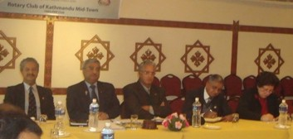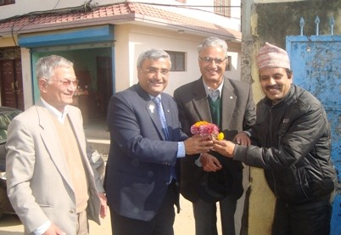
DG Basu conducting Club Assembly DG & District Secretary being greeted
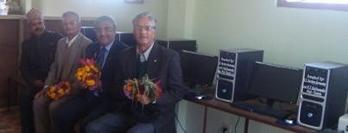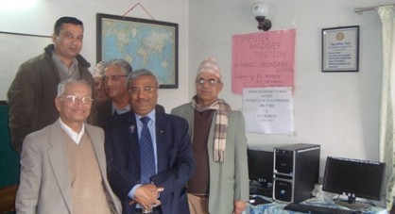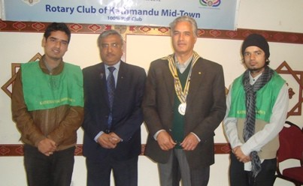

8 December, Thursday:
A program was organized to distribute School uniforms and stationeries to about 280 students ( of KG to Class V) of Janata Primary School at Tistung, Makawanpur, under scholarship support of RC Milano-Villoresi, Italy. DG Basu Dev Golyan was scheduled to witness distribution of scholarship packages, but due to flight delay from Biratnagar (DG Basu Dev was scheduled to visit Tistung after return from Biratnagar by the morning flight same day) he couldn’t make it. IPP Pratap, Rtn Navyo and Rtn Werner and 3 Rotaracts (President Shamir and his team) participated in the program at Tistung. The team was welcomed by Headmaster Dharma Lal Shrestha, School teachers and students.
A good lunch - dalbhat cooked by the mothers of the students, followed the program.
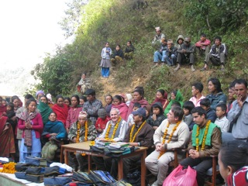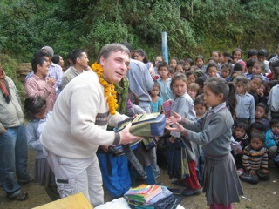

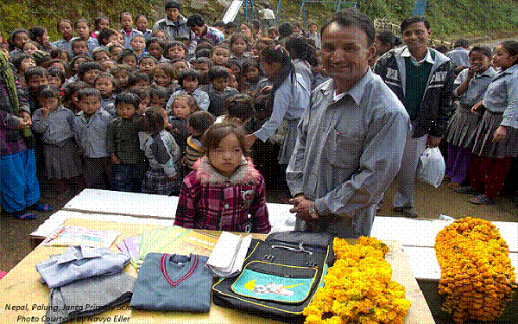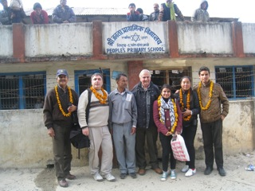

Weekly Meetings and Programs :
Date | Program/Speaker | Program/Topics of Presentation
16 December 2011 | Carol Vernal, CEO of CMAD | Her works in Nepal : establishment of a 50-bed hospital at Itahari
23 December 2011 | Thailand's Ambassador Maris Sangiampongsa | Lessons from Thailand's Rapid Socio-economic Development
30 December 2011 | Steve Dawa Sherpa

16 December, Friday:
Ms Carol Vernal will be giving her presentation on all about Children’s Medical Aid Foundation in Nepal.

What price a comic book sells for ?
Superman comic sells for $ 2.16 million !
A copy of the first comic to feature Superman has sold for $ 2.16 million, becoming the world’s most expensive comic. The comic cost 10 cents when it was published in 1938. The issue of Action Comics No 1 was auctioned online, with a starting bid of just $1. Only about 100 copies are thought to exist, with just a few of them still in good condition. The seller was not revealed, but there are rumours that the comic was owned by Hollywood actor Nicolas Cage.
Source: The Himalayan Times

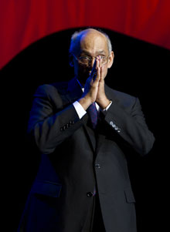
The mother and the child are the core of every family. And the communities we live in are not
built of individual people but of families — families living in homes together, sharing their lives
and their resources and their common destinies. Good families lead to good neighborhoods, and
good neighborhoods build good communities. Good communities make great nations.
RI President Kalyan Banerjee

On Lighter Side : Click here ⇩


A pair of lady fashion shoe!
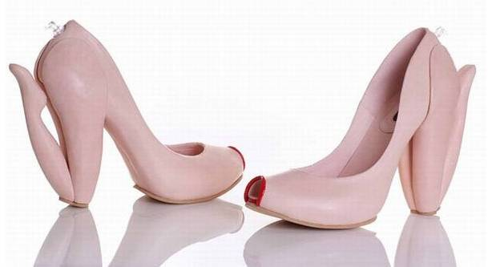

Please send project/activity information, suggestions and photos etc to :
BC Editor: RR Shrestha email: rryes@wlink.com.np

16 December 2011 The Weekly Bulletin of Rotary Club of Kathmandu Mid-Town bc-12.16/011-12

